# **DAY 4 - BUILDING DYNAMIC FRONTEND COMPONENTS:**

**Objective:**

Build dynamic frontend components to display marketplace data fetched from Sanity CMS or APIs while incorporating responsive design and reusable components. Enhance functionality and user experience.

# **The product listing page with dynamic data.**

1. **Optimized Marketplace Data Integration**
   * Leveraged GROQ queries to fetch and display data from Sanity CMS with maximum efficiency.
   * Delivered seamless and responsive data rendering, enhancing the user experience.
2. **Dynamic Product Details Page**
   * Engineered an intuitive product details page showcasing key product attributes.
   * Incorporated essential fields like product name, price, description, and images, ensuring comprehensive product representation.

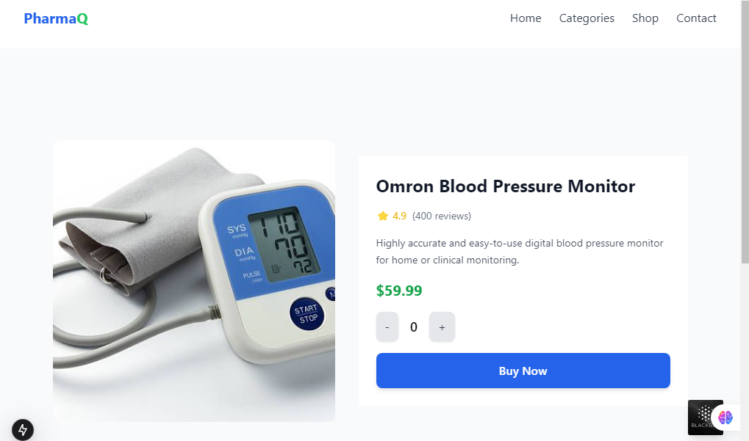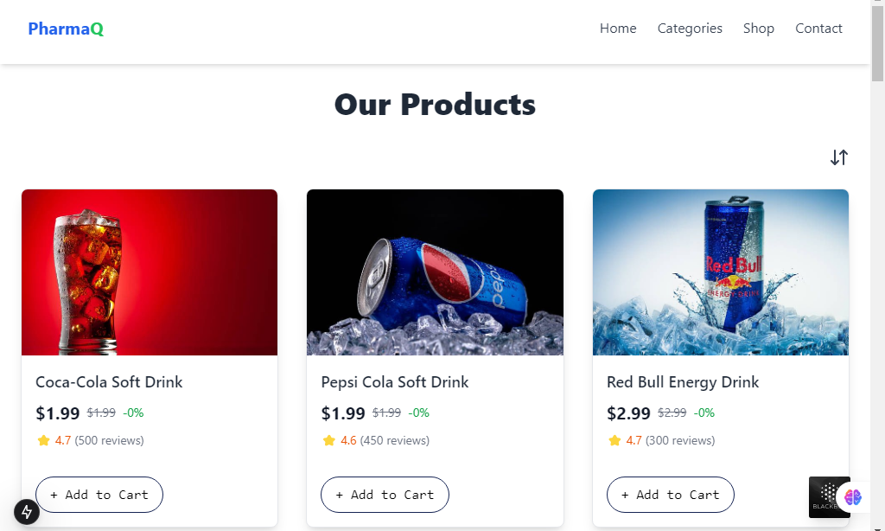

# **Product Filtering Component**

* **Added a filtering feature to sort products by price:** 
  + High to Low
  + Low to High

